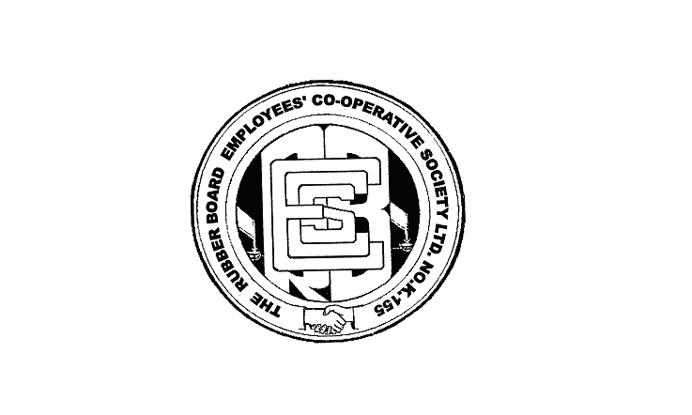
Ref.No.RBECS/166 /2017-18 Date:25.7.2017

NEWS GDCS

Gdcs for Rs.2 lakh duration 40 months and for Rs.1 lakh duration

25 months is proposed to start soon.Those who interested may

remit I st instalment Rs.3830/ and Rs.3400/ respectively,directly

in Society or in any one of the following accounts:

CBI KEEZHUKUNNU BRANCH KOTTAYAM

1559500012

IFSC CODE:CBIN0284150

SBI CIVIL STATION BRANCH KOTTAYAM
67005990629
IFSC CODE :SBIN0070101

